Meyers Gazetteer Online: Meyersgaz.org
Germany “How to” Guide, Beginner Level: Instruction
FamilySearch
September 2024

GOAL
This guide will teach you the importance of using Meyers gazetteer in your research and how to access Meyers gazetteer online found at www.meyersgaz.org.

INTRODUCTION

What is Meyers Gazetteer
                - Meyers gazetteer is a multi-volume gazetteer of all localities in the German Empire (1871-1918). It includes locations that are now in Denmark, France, Poland, Russia, Lithuania, and Czechia and provides information on the jurisdictions of all villages, farms, towns, cities, etc. within the German Empire. The online version of this gazetteer was created by volunteers passionate about German research who wanted this resource to be easier to use. It is available free in searchable form online, with plans to add additional features in the future. This guide focuses on how to use the website version of Meyers Gazetteer.

You may find the following resources helpful in your research:
- Abbreviation Table for Meyers Orts und Verkehrs Lexikon Des Deutschen Reichs
- German Genealogical Word List

When to use Meyers Gazetteer
Meyers gazetteer is the first resource to use if you have a town name and want to locate records for that location. Each entry in the gazetteer will provide information about a location’s historical jurisdictions, with records being kept at specific jurisdiction levels:

Jurisdiction | German term(s) | Record Type
Military district | Bezirkskommando | Military records
Court district | Oberlandesgericht (upper court)  Amtsgericht (lower court) | Marriage contracts, court records
Civil registration office | Standesamt | Civil registration birth, marriage, and death records
Church parish | Kirche, Pfarrei | Religious baptism, marriage, and burial records

For more information on the different jurisdictions for each member state in the German Empire, visit the Germany Jurisdictions page on the FamilySearch Research Wiki. https://www.familysearch.org/en/wiki/Germany_Jurisdictions.

HOW TO ACCESS MEYERS GAZETTEER

Main Page
Meyers gazetteer is found online at www.meyersgaz.org. When first navigating to Meyers gazetteer online, you will have to enter the full URL “www.meyersgaz.org” into the address bar of your browser, making sure to include the initial "www." as part of the URL. This is what the main page will look like:

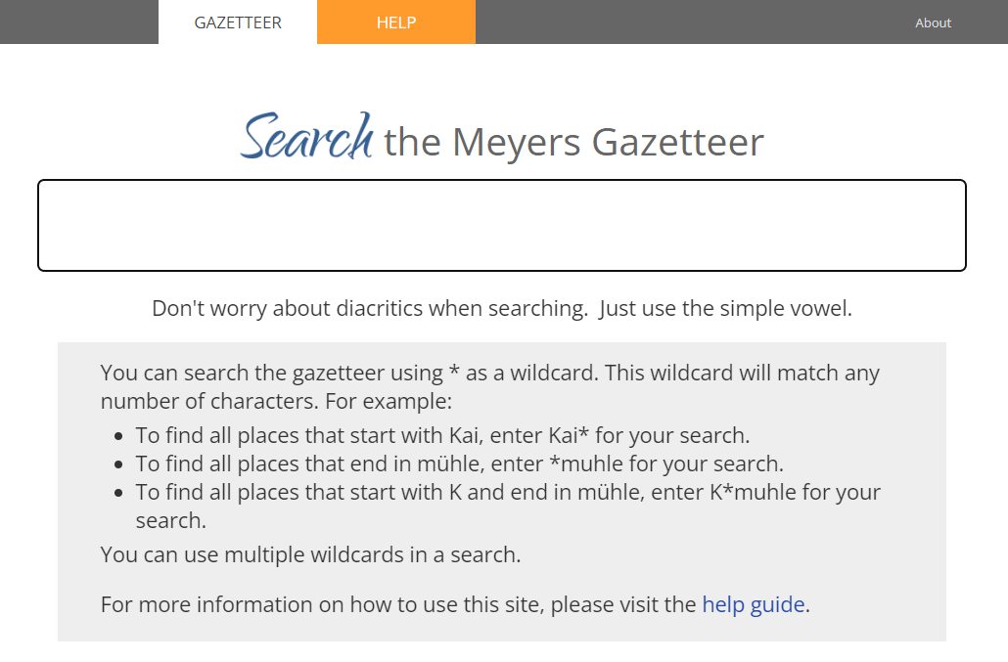
On the main page, you can search for a location in the search box,or you can click on the help tab  at the top of the page for information on how to use the website.

How to Search
Meyers gazetteer online is fully searchable and each entry in the physical gazetteer will have a matching entry online. To navigate to a location’s entry, type in the name of the town into the search box on the main page. The search will only return results that match what is entered and will not return the correct results if the spelling of your search does not match the spelling in the entry. Fortunately, there are several tips to find place names if you are unsure of the spelling or if you only have a partial name of a location:
- Partial-name search: By searching for part of the name, the website will show all results that begin with the letters entered. Thus, if you enter “Neud”, the results include Neudahnerfägmühle and Neudürrlas. However, it will not return any results that do not start with “Neud.”
- Wildcard search: An asterisk (*) can be used as a wildcard to replace any number of characters at the beginning, middle, and/or end of a word. For example, the search for the term “Neud*f” will return results including Neudiesenhof and Neudorf. With the asterisk at the beginning of the search, a search for “*neudorf” will return results including Altneudorf and Welschneudorf. The asterisk can also take the place of all remaining letters. A search for “Neu*” will return results including Neu Abbau and Neuzweiflingen.
- “sounds like” Search: This search is available after you have tried a search, and is found at the bottom of the search results page. It is often helpful if your search term didn’t return the correct location. Clicking the blue words will redo the search and identify any locations that “sound like” your entered search term.
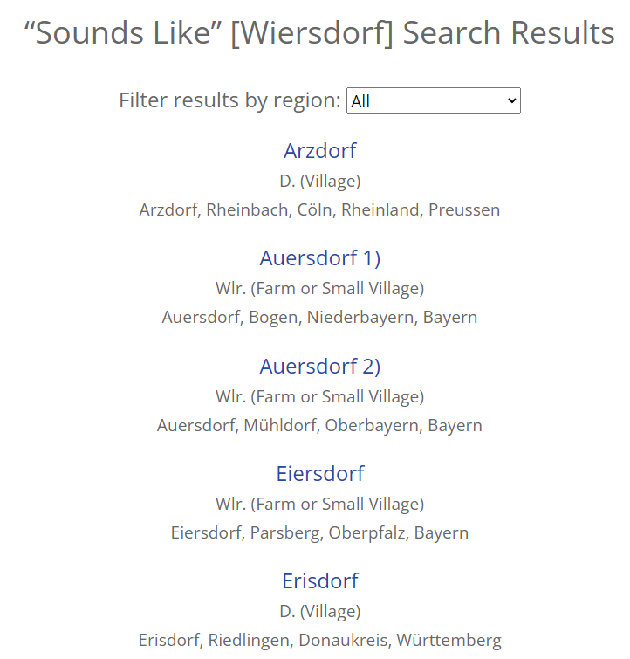
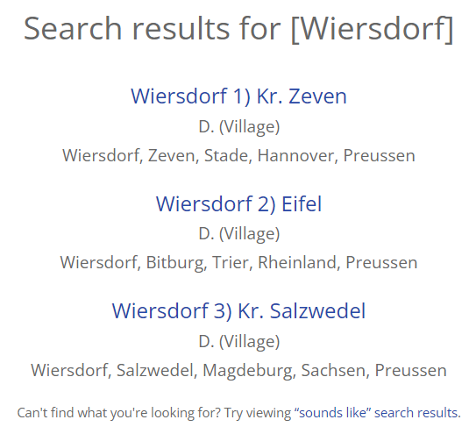

- Umlauts: Many German locations use the umlaut letters ä, ö, and ü. When searching for a location, it is not required that you use an umlaut letter, and spelling out the umlaut in English (i.e. typing ae for ä) will not return accurate results. Searches using a standard letter will return results both for the letter and the umlaut letter as well. For example, a search for “Morsbrunn” will return both locations Morsbrunn and Mörsbrunn.

- Spellings: Many German spellings of locations have been slightly changed since Meyers gazetteer was published. For example, the town of Kassel is spelled Cassel.

  - Try searching using common letter substitutions, such as “a” and “e”, “t” and “d” or “dt”, and “ck” and “k”. More letter substitutions can be found on the German Genealogical Word List on the FamilySearch Research Wiki.

  - Double letters used in a place name may also have changed. Try searching using only one instance of the letter, or using the letter combined with an asterisk (*), so that searches with “tt” become “t” or “t*”.

- Modifiers: German locations may contain modifiers as part of their name, such as klein, alt, nieder, oder, neu, and stadt. To find locations that may include a modifier, include an asterisk (*) at the beginning and end of your search term. For example, a search for “*Allendorf*” will return the locations Allendorf, Klein Allendorf, and Wallendorfer Mühle.

Search Results Screen
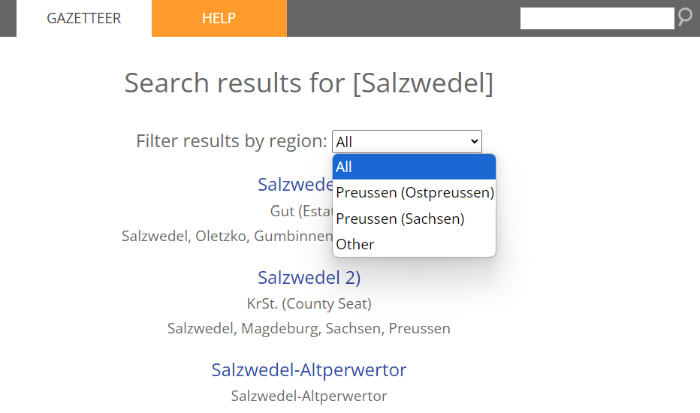
After a search is entered, the results are displayed alphabetically with every result being a clickable link to the main page for that entry. Underneath each result is listed the location type, ex: D. (Village), followed by the location with all its jurisdictions listed from smallest to largest. When a search returns many results across various regions, there will be a dropdown menu option to filter the results by region. From these narrowed results, use any information you know about other jurisdictions to determine which entry matches your location.

If there are no results, you will see a message that says, “No results were found for …”. If you want to perform another location search, or re-enter your search using wildcards, enter the place name in the search box in the upper right corner, and hit the Enter key.

Location Entry Page
Each location has its own main entry page. The page will look like this:

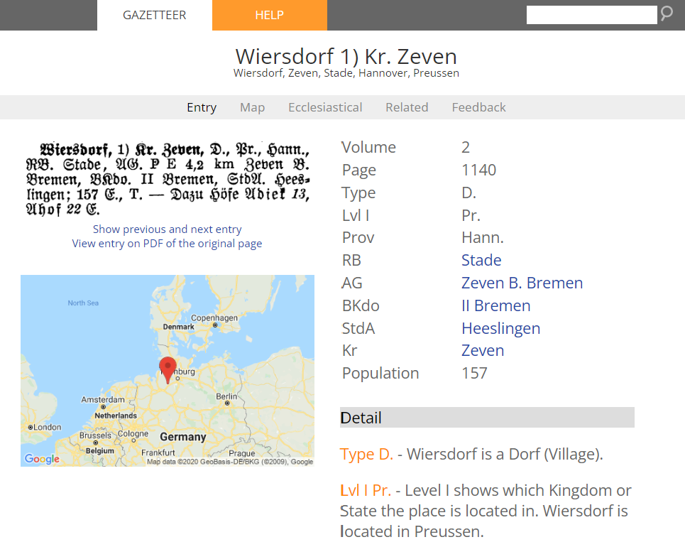
5
3
2
6
4
1

The main entry page is broken into different sections, labeled on the example above. (1) The location name is at the top, followed by its jurisdictions from smallest to largest. (2) Underneath the main heading is a light gray navigational bar with different tabs. The tab you are on will be bolded; as indicated by the bolded “Entry” tab, we are on the entry page. (3) Underneath the main navigation bar, the original entry from the print version of Meyers gazetteer is listed on the left. Beneath that are two links. When the first link is selected, it will display the entries before and after this location from the original print version of Meyers gazetteer. When the second link is selected, it will open a PDF of the original page from the print version of Meyers gazetteer.

(4) Underneath this section is a map showing the location with a red map marker. Clicking on the map will take you to an interactive map located on the “Map” tab in the main navigation bar. (5) Listed on the right is the extracted information from the Meyers gazetteer entry, including abbreviations that are defined in the (6) “Detail” section underneath. The extracted information and the descriptions in the detail section provide you with the jurisdictional information needed to identify where specific records were created, such as civil registration records being created

in the “Stda” or Standesamt. If the location has its own religious center, that will be indicated at the bottom of the extracted information with the following abbreviations:
- “ev. Pfk.” or “ev. K.” to indicate a Protestant parish or church
- “kath. Pfk.” or “kath. K.” to indicate a Catholic parish or church
- “Syn” to indicate a Jewish synagogue.

Map Tab
Many entries in Meyers gazetteer have been identified and linked to an interactive map which combines modern data from Google maps and historic data from the Karte des deutschen Reiches (1893). If the entry is linked to a map, there will be a map included on the main entry page. To view the map, click anywhere on the map on the entry page, or click on the “Map” tab in the light gray navigation bar. While linking the maps is an ongoing project, most entries will be linked to the map.
Once you navigate to the map, you will see a historical map of the German empire, with your town highlighted by a red map marker. The following tips will help you use the map features more fully:
- Moving the map: left click anywhere on the map, and drag the map with your mouse.
- Zooming in and out: use the plus-minus icons located in the lower right corner of the map or use the scroll feature on your mouse or trackpad.
- Full screen: click on the icon in the upper right corner to view the map in full screen.
- Toggling between maps: click on “Toggle Historical Map”, found in the upper right corner, to switch the map between the historical map and the current Google map. You can also view the Google map in satellite form; click on “Satellite” in the upper left corner of the map.
- Showing jurisdictions: hover over “Toggle Historical Map” and click on the box next to “Jurisdictions” to view the jurisdictions for the location on the map. Each jurisdiction will now be marked by a blue map marker with the letter “J”. To identify what type of jurisdiction it is, click on the blue map marker. The abbreviations that appear match those from the location entry page. To remove the blue map markers, hover over “Toggle Historical Map” and click on the box next to “Jurisdictions”.
- Identifying surrounding civil registration locations: hover over “Toggle Historical Map” and click on the box next to “Surrounding StdAs (Standesämter)”. Each surrounding Standesamt, or civil registration office, will now be marked by red map markers with the letter “R”. To remove the red map markers, hover over “Toggle Historical Map” and click on the box next to “Surrounding StdAs (Standesämter)”.
- Finding nearby parishes and synagogues: hover over “Toggle Historical Map” and click on the box next to the desired religious denomination. Catholic parishes appear as yellow map markers with the letter “C”. Protestant parishes appear as green map markers with the letter “P”. Synagogues appear as orange map markers with the letter “S”. To remove the map markers, hover over “Toggle Historical Map” and click on the box next to the denomination. Note that there are some parishes not yet marked with a map marker.

Ecclesiastical Tab
The ecclesiastical tab shows all locations containing a church or synagogue within a 20-mile radius based on distance from the main entry. Each place listed is clickable, taking you to that location’s entry page. At the top of some pages will be a section that identifies which Catholic and Protestant parish is associated with the current location. If this is not present, use the distance column in the chart below to identify which religious centers are closest to the main entry. While the closest locations listed are not guaranteed to be the correct religious center for the main entry, they can often be a good starting point for where to find records. The map tool can also be helpful in providing topographic clues for identifying the correct religious location.

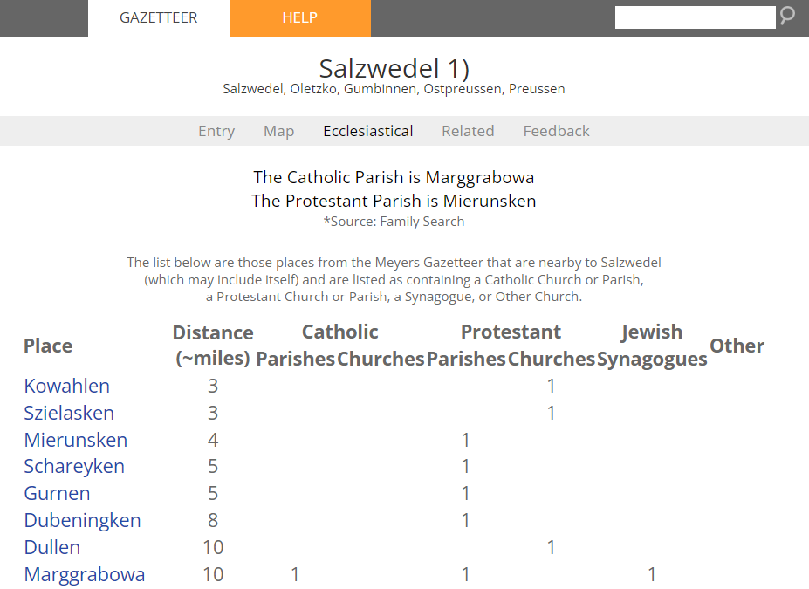

Related Tab
This tab identifies any locations that are connected to the current location. By clicking on this tab, you will see a list of entries where your location is referenced as a certain jurisdiction. For example, if the location page you are on is also a Standesamt (civil registration office), this page will list all entries in which this location is their Standesamt.
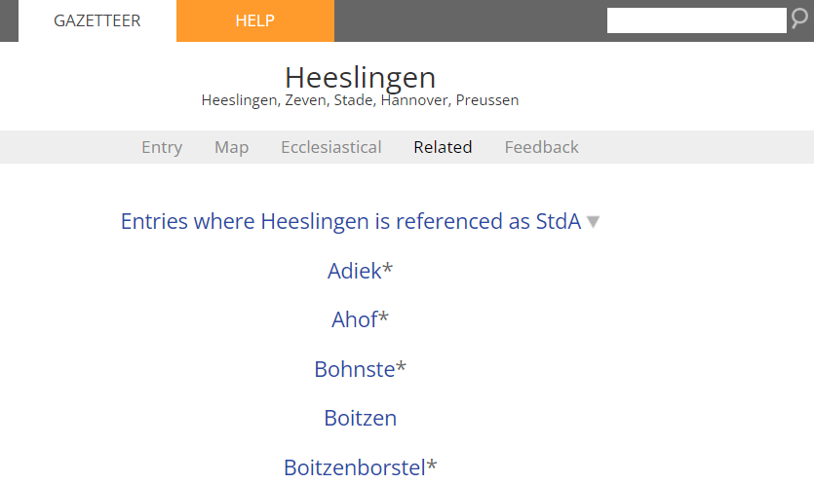

Feedback Tab
This tab allows you to provide feedback on any errors you find or any suggestions you would like to make. Simply enter your name, email, and any comments you have, then click submit to share your feedback.

PRACTICE
Go to Meyers gazetteer online at the website www.meyersgaz.org, and follow these steps.
- Type in the town location Mottgers. There is only one entry for this town; click on the blue “Mottgers” entry name to navigate to the entry page.

- Read through the jurisdiction information found in the right column. Read through the details to understand what the abbreviations are. You will find that Mottgers is a village, located in the kingdom of Preussen (Prussia), in the province of Hessen-Nassau, and the Kreis (county) of Schlüchtern. According to the entry, court records are found in Schwarzenfels B. Cassel, military records are found in Hanau, and civil registration records are found in Mottgers. The town also has a protestant parish.

- Click on the “Map” tab in the light gray navigation bar or click on the map on the entry page. Hover over “Toggle Historical Map” and select jurisdictions. Zoom out on the map until you find Schlüchtern – it is located west north-west of Mottgers. Click on the blue map marker; the entry shows that Schlüchtern is a Kr, meaning Kreis or county.

- Now, click on the “Ecclesiastical” tab in the navigation bar. Here you find that the nearest Catholic parish is in Sannerz, approximately three miles distant. The nearest Jewish synagogue is six miles away in the town of Brückenau.

- Now, click on the search box in the upper right corner of the website, and type in the new location of “Di*heim”. Look at the results; notice that each entry fits the wildcard search you just entered. Scroll down until you find the entries for Dietersheim; there are three. Select “Dietersheim 3)”, located in Freising, Oberbayern, Bayern (Bavaria). Look in the jurisdictions column on the right; it tells you very little about the location, but tells you “See Eching”. In the column, click on Eching. Now you should see more information about jurisdictions. You may also see that Eching is not currently linked to a map location.

© 2024 by Intellectual Reserve, Inc. All rights reserved. No part of this document may be reprinted or reproduced in any form for any purpose without prior written permission.

