FamilySearch Family Tree: Record
Hints and Sources

Objective: At the end of this class, you should be able to attach a source using a record hint. You will also understand how to add other types of sources.

Record Hints
FamilySearch tries to do some of the work for you. As more indexed records become available, you are more likely to find hints on your tree. To find a hint, look for this icon:


When you see this icon, the FamilySearch algorithm has decided that the person in the record and the person on FamilySearch Family Tree have a high probability of being the same individual. However, it is important to remember that this does not guarantee that they are the same individual.

Go to the following link for a detailed list of instructions on attaching record hints: https://www.familysearch.org/en/help/helpcenter/article/how-do-i-attach-record-hints-in-family-tree

If the hint is not a match for your ancestor, visit this link: https://www.familysearch.org/en/help/helpcenter/article/what-do-i-do-with-record-hints-in-family-tree-that-arent-a-match

Sources
Sources are an important part of research. They give proof that a person existed, or event occurred. There are six fields on Family Tree when adding a source.

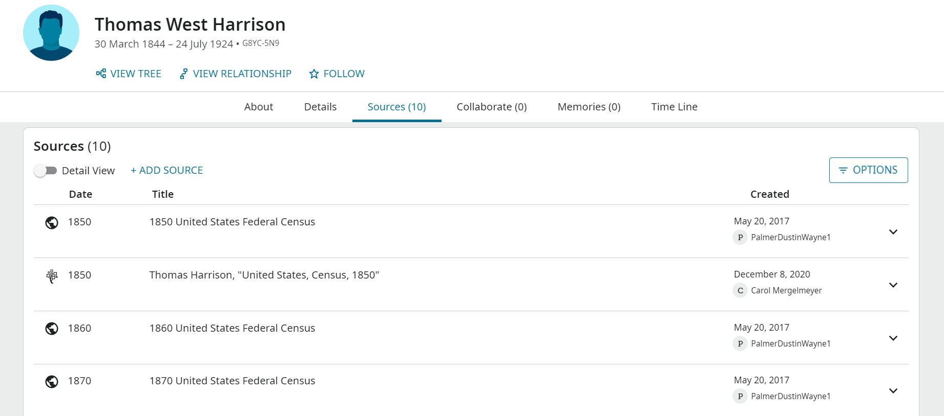

Event Date:
The date used in this field is typically the date of the event that the source identifies. The importance of this is to help you identify which event is being sourced as well as organize your sources in chronological order. There different options for entering the date. You can enter the full date, or you can enter only the year. The minimum that we recommend is the year.

Source Title:
This is the only required field when adding a source. This is the title of the source. We recommend that you use a simple title that describes what the source is. A good example of this could be something like “1848 Birth of John Doe.” If you have included an event date, you do not need to include the year in the source title.

Source Type:
This allows you to pick between adding a URL or Memory of your source. When adding a URL, it is important to remember that URLs are rarely permanent. We recommend, when possible, to upload a Memory. The Memory option will only allow you to add image files as the Memory for your source. You will need to follow the FamilySearch Content Submission Agreement when adding a Memory.

Citation:
In our opinion the citation is the most important of the source. It is used to let other researchers know exactly where a record or document can be found. A good citation will allow a researcher the ability to find the source even if the URL is broken. As there are many ways to cite a source many researchers in Family Tree follow the Chicago/Turabian source citation style. A great resource for citing sources is Evidence Explained by Elizabeth Shown Mills.

Notes:
The notes field allows you the ability to include information about the original source. Many researchers like to include an abstract/extract of the information found in the source. Some researchers will include a transcription or translation of the record.

Reason to Attach:
This field gives you the ability to explain why you believe the individual in the source is the same as the individual on Family Tree. See below for more information about Reason Statements.

Vital Tags:
This area allows you to tag specific events and information to the source. You are only able to tag the following: Name, Sex, Birth, Christening, Death, and Burial

Reason Statements
Any time you go to make a change on Family Tree, you will be prompted to include a reason statement. These statements are your opportunity to explain why you believe the information is correct. Although this field is not required when editing Family Tree, we recommend that you ALWAYS take time to add an explanation as to why you are editing or adding information.

As Family Tree is an open-edit tree, reason statements are essential for helping users work together. These statements can be short or lengthy. Answering the following questions can help you create a good reason statement:

- How do you know the information in the record is your ancestor?
- Do the relationships mentioned in the record match what you already know from other records?
- Does the date/event place come from a specific source? If so, which source and how do you know it is correct?
- Is it possible that two people lived in the same town at the same time with the same name? If so, how do you know that you have two individuals instead of one?
- How do you know that this is the correct child of these parents?
- What sources/records have you found that prove the information you are adding to be correct?

© 2025 by Intellectual Reserve, Inc. All rights reserved. No part of this document may be reprinted or reproduced in any form for any purpose without prior written permission.

