FamilySearch Family Tree: Correcting Relationships

Objective: Learn how to effectively correct relationship errors in the FamilySearch family tree through best practices and analysis.

Because FamilySearch is working towards building one giant family tree for all of mankind, and it is a large collaborative effort, errors are inevitable. There may be duplicate individuals listed in the same family, incorrect parent-child relationships, and individuals who don’t belong in the particular family you are researching. These problems can be resolved by deleting duplicate relationships, merging, and careful analysis.

Analysis: When determining if there are errors in the family you are researching, you should carefully review the following information:
- Names of the person or family members
- Dates the person lived
- Locations where the family or person lived
- Reason statements from other FamilySearch users
- Sources either attached to those in your tree or that may have been found in previous research
- Discussions that may have been started for your family or individual
- Notes and alert notes that you or others have kept regarding the individual or family
- Life Sketches
- Relationships
- Research Help suggestions from FamilySearch

These links are for articles from FamilySearch explaining the different reasons you may see these icons in your family tree:


https://www.familysearch.org/en/help/helpcenter/article/what-are-all-the-possible-data-problems-in-family-tree


https://www.familysearch.org/en/help/helpcenter/article/what-are-all-the-possible-research-suggestions-in-family-tree

It is helpful to look at the individual you are researching in the context of their immediate family. Seeing if a person was married more than once can help determine if certain children are from one marriage or another. Birth years of siblings can be a good indicator of whether a child may be missing or if a child may not belong to a particular family.

Commonly Seen Practices: Families may not always follow the perfect cookie-cutter style, but these commonly seen practices can give an idea of what may have occurred and suggestions for future research.

- Children born 0-2 years after marriage: generally, if it was a couple’s first marriage, they may have had a child 0-2 years after their marriage. They may even have one child born a little before the marriage.
- Children born 2-3 years apart: if there is a gap between siblings of more than 4 years, there may be a child missing. This isn’t always the rule, but it is helpful in figuring out if children are missing or if the birth order makes sense. If there is a 10-year gap between children with no other children between them, it may be helpful to research a bit more.
- Vital events happen where the family lived: if your family is from England and never left, then the family living over in Kentucky at the same time with the same names is probably a completely different family.
- Widow(er)s often remarry especially if they have small children: a widower will often remarry to have someone to take care of his children shortly after the death of his first wife so he can continue to work and provide for the family.
- Naming patterns: naming patterns vary from place to place. One common naming practice is to name a child after a sibling who died young. If you see two children with the same name, often it means the older one died before the second was born. Occasionally families did have two children alive with the same name even though that sounds weird to us.

Fixing Relationships
After determining if errors exist within the family, there are a few ways to resolve them. Before changing any information, it can be helpful to write down the names, ID numbers, and relationships of the ancestors involved. It is helpful to have a visual of the family and where the errors exist. Remember that you can always view a list of recent changes to any individual and undo any changes if you make a mistake.

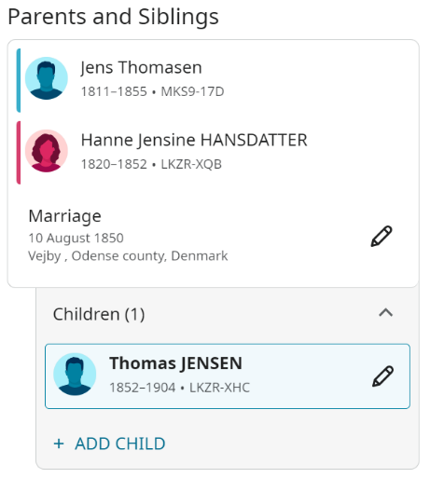
If connected to the same parent twice: Follow these steps:
- Signed into FamilySearch.
- Go to the person page of the child who is connected to duplicate parents.
- Scroll to the Family Members section. Find the child under the parent with an unknown spouse.
- Click the Edit icon.

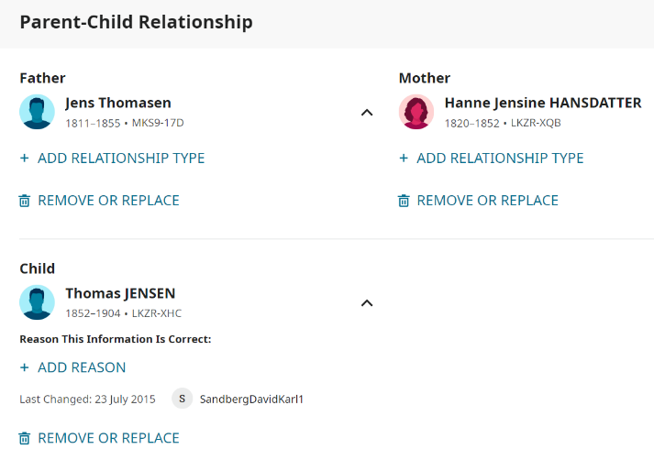
- Beside the child's name, click Remove or Replace or Delete Parent-Child Relationship at the bottom of the box.
- To indicate that you reviewed the relationships, sources, and notes for the individuals, click the check box.

- Click Remove Parents or delete relationship.
- Explain why, and then click Remove.
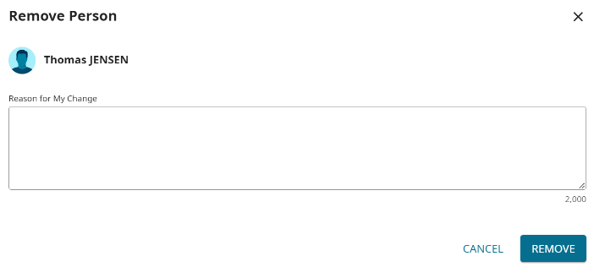
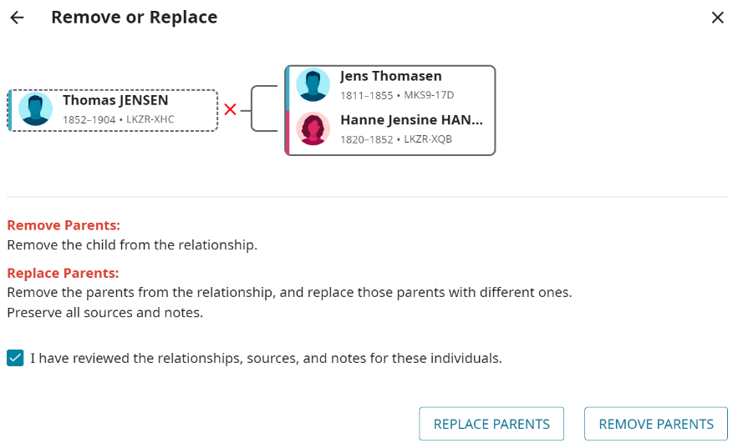
- Refresh the page. You should no longer see the child and the single parent.​

If duplicates are listed: Follow these steps:
- Make sure you are signed into FamilySearch.
- Go to the person page of the person that has the duplicate listed (This may be the individual themself or it can be on a relative’s page such as a spouse, child, or parent’s page.
- Click on the ID number of the duplicate and select to copy the number.
- Go to the person page of the person you would like to merge the duplicate with
- Scroll down until you see the Tools section.
- Select Merge by ID.
- Type or paste the ID number of the duplicate into the field provided.
- Continue the merge.
If a person doesn’t belong: If someone is connected to a family and they don’t belong for one reason or another you can follow the same instructions as listed above for editing or removing the relationship. If the person is related, but just listed in the wrong place you can add them to the correct family or possibly merge duplicates that may exist between the families.
Other Helpful Articles on FamilySearch:
All these articles come from the FamilySearch Help Center and can be found by searching for these titles listed below or by clicking the links.
My ancestor in Family Tree is connected to the same parent twice
The same child shows more than once in a family in Family Tree
A person in Family Tree has the wrong spouse
How do I correct parent-child relationships in Family Tree?
How do I see what changes were made about a person in Family Tree?
How do I merge possible duplicates in Family Tree?

